Resources for Reconciling In Christ (RIC) Sunday
January 25, 2015
Third Sunday after Epiphany

Introduction
Every year, ReconcilingWorks: Lutherans for Full Participation offers resources for Reconciling In Christ Sunday, the last Sunday of January. This Sunday is recognized ecumenically throughout the welcoming church movement. For faith communities that have made a public stand in welcoming people of all sexual orientations and gender identities, this Sunday is set aside to highlight our shared ministry of hospitality and reconciliation.

Again this year, the resources we present for RIC Sunday are based on the Revised Common Lectionary texts appointed for the day, the Third Sunday after Epiphany. As we pondered the appointed lessons, we heard themes of God’s call to us, to gather us, comfort us, and send us out. We heard invitations to repent and to believe from this God who remains in relationship with humanity.

May this resource help you plan your own RIC Sunday celebration! Let the scripture notes inform your worship and sermon preparations. Use the children’s sermon ideas to discuss your community’s commitment to welcome with your kids. Select hymns from the list below, or seek out new songs to sing. Include or adapt these prayers of the people petitions in your own worship. Use any or all of the liturgical elements (Affirmation of Baptism, Call to Worship, Prayer of the Day, Offertory Prayer, Communion Liturgy, Post-Communion Blessing, Sending Rite, and Dismissal) to renew your community’s commitment to being a place of welcome for people of all gender identities and sexual orientations. Feel free to adapt these resources to better fit your specific worshiping community. Let these resources inspire ways that your worship can celebrate, renew, and grow the mission of inclusion to which we have heard God calling us.

Should your community be unable to celebrate RIC Sunday on January 25, feel free to select a date that works better for you, such as a date near National Coming Out Day (October 11) or the anniversary of your joining the Reconciling In Christ program, or in conjunction with the local LGBT Pride celebrations. You are encouraged to adapt these resources for use at other times.

As you consider the many ways your community might expand and deepen the commitment you have made through the RIC program, consider also the ways that you can support ReconcilingWorks in reaching out to new potential RIC settings as well as continuing to help current RIC settings deepen what it means to engage in this ministry. Consider taking up a special offering for ReconcilingWorks on this day. Encourage individuals and households to sign up as Reconciling Lutherans, as paid members, or by scheduling regular giving through our Evergreen Giving program. If your congregational meeting is being held on or near Reconciling In Christ Sunday, make sure that support for ReconcilingWorks is included in your community’s annual budget. For more information on ways to support ReconcilingWorks, visit our website here: www.reconcilingworks.org/get-involved

So that we know how best to serve you, please let us know when your RIC setting celebrates RIC Sunday this year. We would also appreciate your feedback on these resources. Feel free to forward to us other resources that you use in your celebration which we could share with others for future RIC Sunday celebrations. We also love being able to share your RIC Sunday plans, pictures, and stories on our Facebook page www.facebook.com/ReconcilingWorks. You can forward photos and content to Grassroots Organizing and Training Coordinator Tim Feiertag (grassroots@reconcilingworks.org) as well.

Thank you for your partnership in ministry through the Reconciling In Christ program. May these resources enrich, challenge, inspire, and deepen your community’s commitment to welcome people of all gender identities and sexual orientations!

The Scriptures

Jonah 3:1-5; 10

Jonah is likely one of the stories of prophets that is most well-known. As children we hear of the man who was sent by God, ran in the other direction, and ended up in the belly of a whale (more appropriately “big fish”).

Today’s reading picks up after Jonah is spat up onto the shore. In this lectionary selection Jonah goes, if begrudgingly, to Nineveh and proclaims the wrath of God on the city.

Ideas and Questions for this text
- What does it mean to be a prophet and speak a word that calls for change? On this Reconciling In Christ Sunday, it is important to note that there are those who have called for the church to change or repent…and whole communities have been transformed. This can be a powerful witness. Yet, there are also individuals and communities that have continued to struggle; those where the initial prophets have been characterized as troublemakers; times when those who have spoken or lived a prophetic word have felt frustrated that God’s vision has become the reality, and it’s hard to see God’s mercy expanded in all directions.

The story of Jonah may allow opportunities to tell the stories of prophets who have come into communities (or stuck with them) and have spoken a new word. This may be a time to reflect on the 40 years ministry of Lutherans Concerned / ReconcilingWorks—speaking to a church that has worked to follow a word of mercy and hope. This may be a time to hold out hope for the prophets who continue to call us to repentance in areas of reconciliation (sexuality, racial justice, economic justice, care for the environment) and continue to call us to renewal.

- When reading this text it may be useful to lift up Jonah’s words of wrath. Jonah does not speak a word of hope or promise, yet somewhere in his presence and words of wrath the people heard a crack…wrapped in words of tumult, the people heard an opportunity to change.

Is it possible that in the words that have been (or continue to be spoken) we hear a word of hope for today? Is it possible we hear an opportunity for transformation? Just when we become comfortable, could it be that we will hear a voice that pushes us into another uncomfortable confrontation with God’s word for us—perhaps speaking out against bullying, committing to work and conversation on transgender inclusion or bisexuality?

- It may also be possible to address the role of the reluctant prophet. For congregations where this RIC ministry has been carried out by parents, grandparents, siblings, or other family or friends of LGBT individuals, it may be important to note that many of them were likely reluctant prophets. Speaking a word of inclusion or welcome may have been an uncomfortable or isolating path. It can be powerful to know that God uses the reluctant prophet and provides a message.

While we may want to run from the path God sets before us, God continues to draw us out and into transformation—being transformed ourselves; transforming communities.

Psalm 62:5-12

Psalm 62 offers a vision of safety and promise. It holds out hope for individuals and communities.

Ideas and Questions for this text
- The reading of Psalm 62 can bring out a variety of reflections and responses. Imagine a teenager who cries himself to sleep with the knowledge of being “different” from others—what does it mean to hear and cling to the promise of a God who comes? What does it mean to rest in God who is a mighty rock and refuge? What does it mean to be a congregation that has struggled in the wake of the ELCA vote in 2009 and to hear the words of putting trust in the Lord at all times and pouring out your heart before the Lord?

There is an opportunity to utilize this text as one of longing, of lament, and certainly of promise of power and love that God pours out.

- If the preacher would like to tie this text more closely to the story of Jonah, the words “Once God has spoken; twice I have heard this,” offer an opportunity to connect. In Jonah we hear that a second time the word of Lord came to him.

What are the ways that God’s voice/God’s word has come to us again so that we might hear and step out in faith? Are we listening to the word of One to whom power and steadfast love belong? Are we living this witness in our lives as individuals and communities? We listen to God’s call and respond.

1 Corinthians 7:29-31

The text from 1 Corinthians is one that can be enigmatic for people today. Few anticipate Christ’s return in the matter of days or months. In much the same way, Christians in Canada and the United States do not live under the threat of martyrdom or persecution. The community to which Paul writes seems removed from the context of life today.

The opportunity is to focus beyond our time, our household and look to the promised realm of God.

Ideas and Questions for this text
- The Corinthians passage opens the conversation to living in boldness in the world, as if the current state of affairs does not matter. Beyond marriage and family status, mourning and weeping, rejoicing, and trading in the possessions and dealings of this world, we look to a world that is in the process of being transformed by Christ.

On this Sunday the opportunity exists to examine how we might live faithfully and boldly in a world that is undergoing transformation...a world in which we anticipate Christ to enter at any time. Whether literal or metaphorical, we look to Christ coming into the world in each and every moment—in each person we encounter, in each moment of ministry, in the promised realm yet to unfold.

- As this passage unfolds, it provides an interesting juxtaposition to the work of many in the LGBT movement. Recent work and victories allow for same-gender couples to marry throughout Canada and in thirty-four states in the U.S. (as of November 20, 2014). How do we hear this text from Paul that tells people to live as though they have no wives (read spouse)?

This may be an aspect that allows for conversation around relationships and the “in-between times” in which we live. It may also open the door to conversation around “created family,” and exploring ways to live faithfully in the midst of changing times.

- If your congregation has global connections, particularly in areas where lesbian, gay, bisexual, and transgender individuals or communities face persecution, it may be significant to speak a word of solidarity. Paul wrote to the people of Corinth in a spirit of solidarity, building of community, and looking toward a day in which God brings about renewal.

Mark 1:14-20

The Gospel for today is rich in images and sense of vocation. On this Reconciling In Christ Sunday we allow this text to inform, equip, and call us to further live out the call to follow Jesus.

Ideas and Questions for this text
- Today there is widespread agreement of the Gospel of Mark being the first of the gospels to be written. In this first of the gospels the initial words we hear from Jesus are, “The time is fulfilled, the realm of God has come near.” What an incredible message! Yet we understand that this witness is a now and not yet. For many in the ELCIC and ELCA there is a realization that a new reality has set in with openness to LGBT rostered leaders at the policy level; still we know that there are congregations that do not welcome LGBT individuals and families, many congregations will not consider calling an LGBT pastor, many communities still wrestle with same-gender marriage or speaking out on bullying.

Additionally, even in those communities that have stepped out in faith on the issues of sexuality and gender identity, there are ways in which work on racial justice and greater inclusion are not fully lived. We live in a “now and not yet” realm of God. This text offers the opportunity and challenge to leave the nets of comfort and step out in faith.

- It is important to note that there are individuals and congregations still deeply wounded and pained by the policy changes in our churches. One opportunity for pastors addressing these pains is to talk about the brothers, James and John, and their father Zebedee who are mending the nets.

It may be useful to explore the ways that we continue to mend our nets from the work of the days before. Are there ways that we come together and allow for mending and renewal? From that point there may be some who are ready to step out in new ways in following Jesus; there may be some who still need to sit in the boat and continue the work of mending.

- In contrast to the reluctant Jonah, in the gospels we appear to have eager followers who are willing to leave their lives as they know them and step out boldly in following Jesus. Are there people to highlight in each congregation who have eagerly and powerfully stepped out—leaving the comforts of life as they knew it behind? What has it meant to the congregation and to the ELCA and ELCIC to step out in faith? What has it meant to listen to the voice of Jesus that has called us or calls us today to enter into a new journey?

Children's Sermon Ideas

Bring a cell phone or other phone and ask the children what it is. What is it used for? This is an opportunity to think about call. What does it mean to receive a phone call? Someone wants to connect/talk with you…someone might have information for you. In the texts for today we hear God calling people to speak, to serve, to follow. How does God call us today? We hear God’s call through Scripture, through the voices of those who call us to live faithfully. Share that this congregation has heard the call of God in learning, reading, living together. The call has been one of being faithful to God’s love and welcome for all; this call is one of boldly following Jesus.

Another idea is to have mesh or net with paper fish attached (made out of rainbow colors of construction paper). Invite the children to grab hold of the net and pretend that they are Simon (or Simone), Andrew (or Andi), et al., then have an adult come by and call out to them to follow. Give each child two of the rainbow fish…the person who calls them can draw a cross on each of the fish. Invite them to take one of fish out into the congregation and give to someone. The call of Jesus is to go out and share the rainbow of promise with others. Today we continue to hear that call and go out from the church to share God’s love with everyone.

For many children the idea of repentance is quite abstract. It may be useful to bring in road signs (wrong way; u-turn; this way). Invite the children to pretend they are walking or driving a car. As they walk they come to a sign that says “Wrong way” or “Dead End.” Have an individual come along with a sign that says “U Turn” and perhaps another with a sign that says “This way.” You may talk about how the people of Nineveh are going the wrong way—they are doing things that aren’t faithful to God. Jonah arrived with a sign to turn them around. The leader of the city then turns the people around and points them “This way” into a new direction. There are times that all of us can go in the wrong direction. God then calls us to turn around or “make a U-turn” and live in a new way.

Hymn Suggestions

As you consider what music your community will sing on Reconciling In Christ Sunday, below are several options from Evangelical Lutheran Worship (ELW) which fit the lectionary texts for the day as well as the broader themes of reconciliation, welcome, and inclusion. ReconcilingWorks has long maintained a commitment to inclusive language in our worship. The hymns below reflect those commitments as well, avoiding solely male gendered language for God and humanity. Also avoided is language that excludes transgender and gender nonconforming people due to a presentation of an exclusive binary system of gender (“men and women” or “brothers and sisters” for example). Scroll to the end of this list for additional hymn suggestions!

#306 “Come, Beloved of the Maker”
Filled with the Epiphany season’s light imagery, this song includes Christ’s invitation to follow as heard in the Gospel reading. For congregations or individuals who have been hurt it speaks of God’s transforming love.

#418 “Rejoice in God’s Saints”
Reflecting various forms of faithful service, this hymn celebrates diverse examples of saintly living. Perhaps this could connect with celebrating the many ways your community lives out your RIC commitment.

#507 “O God of Light”
With a reading from Jonah, today is a great day to lift up the reluctant prophets (verse 2). Both eschatological hope and God’s present invitation are named.

#523 “Let Us Go Now to the Banquet”
The joy of gathering together leads the singer to continue expanding the invitation to all, working toward a place “where all people are equal in love” (verse 3).

#530 “Here, O Lord, Your Servants Gather”
We respond to Jesus’ call to follow, knowing that Christ is also the Way of our following. This hymn also speaks of unity in diversity and trusting in God to respond to our needs.

#572 “Now It Is Evening”
Here is a musical option specifically for evening celebrations of RIC Sunday. This song invites us to reach out to be neighbor to those who are hungry, who are neglected, and who are as yet unknown to us.

#581 “You Are Mine”
In the refrain, we sing Christ’s invitation to follow. Several images from the psalm are included (silence, hope, an end to fear and shame, hearing God call, finding shelter in God).

#603 “God, When Human Bonds Are Broken”
Recognizing the ongoing work of reconciling to one another, this hymn names the stillness from the psalm as a beginning of healing and reconciliation.

#605 “Forgive Our Sins, As We Forgive”
“. . . by your mercy reconciled, our lives will spread your peace.” If conflict and resentments remain within your community, this hymn may be a way to name that challenge and invite healing to continue.

#613 “Thy Holy Wings”
A place for all God’s children can be found in the feathery comfort of God’s embrace. Adding another layer to the metaphor, God is simultaneously named as our rock (Psalm 62:6).

#641 “All Are Welcome”
This hymn of broad welcome illustrates many faithful ways congregations are able to move from hurt and injustice to mutual community and sharing the love of God. To sincerely declare everyone welcome can be especially precious to LGBT people who may have heard elsewhere that they are not.

#653 “Where True Charity and Love Abide”
This ninth century hymn speaks of the ongoing need for reconciliation within Christian communities while anticipating the joy of the fullness of time.

#677 “This Little Light of Mine”
When we follow Christ, let’s be sure that our Epiphany lights are shining brightly!

#704 “When Pains of the World Surround Us”
Responding to Christ’s invitation to follow opens us to be channels of God’s healing, justice, Spirit, and changes for a hurting world in need.

#767 “Lord, Take My Hand and Lead Me”
The Rock of Ages is near us in times of trouble. Christ’s guides us on the way as we respond to the invitation to follow. The hymn ends in hope for our final days.

#817 “You Have Come Down to the Lakeshore”
In this hymn, we imagine ourselves as the fishers who receive Jesus’ invitation to follow, sharing God’s love as we go.

In addition to songs from our hymnal, you are also encouraged to seek out hymns and songs appropriate to the day that might be new to your community. Here are some ways to pursue that option.

Two websites to check out:
David Weiss has been a frequent contributor to ReconcilingWorks resources, writing hymns and liturgies. On his website http://tothetune.wordpress.com/writings/hymn-texts/ he lists several hymn texts which can be sung to familiar hymn tunes. The website describes how to gain permission to use those hymns in worship.

David Lohman is a staff member at our partner organization, the National LGBTQ Task Force’s Institute for Welcoming Resources. His music has been used at several ReconcilingWorks events as well. On his website www.welcomesongmusic.com/songs.html you can sample and purchase several of his compositions. To witness a very powerful use of his hymn “For All the Children,” follow this link to a YouTube video: http://youtu.be/3wLQ63LMC-A

How else could you find new songs to sing? Ask nearby welcoming congregations of other denominations what songs they sing to celebrate their commitment to hospitality. Perhaps you have a poet in your midst who could write new words to a familiar hymn tune. Are there hymns you heard at a conference (such as a gathering of ReconcilingWorks) or at a synod assembly that you can get permission to use? These are some ways to expand your musical repertoire!

May the Good News of God’s extravagant love be heard in our singing!

Options for Prayers of the People

Mending the Net in Prayer: Interactive Intercessory Prayer
As in the gospel reading, Jesus found John and James mending their net, symbolic perhaps of the ministry they will be called to be a part of in God’s reign: mending and reconciliation. The congregation is invited to write prayers of thanksgiving and supplication, in areas of life where reconciliation has been a blessing or is very much needed, on a ribbon or strips of fabric provided to them before the service begins. These prayers will be lifted up during Intercessory prayer and they will be invited to weave their prayer ribbons into the net strategically placed as they come forward for Holy Communion. You are free to embellish or add to the creativity in order to increase participation through deep reflection and commitment to reconciliation.

Materials
- Net. You could get a variation of this from any hardware or garden store. One option is the plastic netting used for gardening, covering small plants for protection from deer, with square (small or big) holes.
- Pen or Markers
- Ribbon or Strips of fabric. Preferably in rainbow colors or if you want to match the liturgical color, in shades of green.

Instruction during worship (either written or announced before offertory)
Today we remember God’s calling to Mend and Reconcile. These gifts are at the heart of our discipleship call, and tasks that we continue to participate in as long as there are members of our community excluded from the table of Christ, especially our LGBT community and their families. John and James were mending their net before they were called to discipleship. Even though they left this specific task, they continued it in various ways towards building God’s reign in the world.

Intercessory Prayers

For the Church, in our call towards radical love, reconciliation, hospitality and unity
Reconcile your people, O God (or the last phase of ELW #247 “Come now O Prince of Peace” Reconcile your people – the music/humming of the song may continue)

For communities, cities and nations, where no one is excluded or discriminated against, and where love is our rule and justice is our practice
Reconcile your people, O God

For people in our lives and those unknown to us, who need healing, care and compassion, and those in the midst of conflict, violence or war
Reconcile your people, O God

For people working for justice, peace and reconciliation, that in humility they serve, in courage they speak out, and in faith they persist
Reconcile your people, O God

For those who have gone before us, especially the LGBT leaders who paved the way to reconciliation and inclusion in our communities, may we join them in their legacy
Reconcile your people, O God

The minister and the people say

We shall all be reconciled in Christ
United and one in our life together
Praise to God who has loved and created us
Praise to God who has lived with us and accepted us
Praise to God who dwells with us and sends us into the world.
Amen.

Liturgical Options

Affirmation of Baptism
Leader: The time is now.
Congregation: The kin-dom of God has come near.

Pastor: Today, we reaffirm the baptismal promise of God’s love that was marked on many of our foreheads with water, Spirit and oil. For many of us, this sign of God’s love happened when we were too young to remember it, before anyone could know who we would become, the choices we would make, how our bodies would transform or whom we would love. Others were able to bring the fullness of themselves to the baptismal font and experience the unconditional love of God.

Regardless of when baptism happens, these waters create a loving and eternal covenant with God and enable the gathered faithful to commit to supporting, loving, and instructing the newly baptized.

Like the Israelites who wandered in the wilderness for years, Jonah’s stubborn descent into the belly of a whale, and the motley disciples who do their best to understand Jesus’ parables, our faith journey is full of ups, downs, and trying to do our best.

Today, at these baptismal waters we recommit ourselves to proclaiming a full welcome to all God’s children and commit ourselves to reconciling with the individuals and communities of all sexual orientation and gender identities who have felt like God’s promises were not available to them.

May these swirling, cleansing waters affirm the fullness of who you are and inspire you to proclaim God’s love and reconcile with others.
espurging or drawing up and pouring of water into the font
May this living water assure you that you and your family are affirmed and loved by God.
espurging or drawing up and pouring of water into the font
May each drop be a blessing from God on all of the fearfully and wonderfully cells in your body.
espurging or drawing up and pouring of water into the font

Refreshed by these waters, let us prepare our hearts and minds for worship.

Call to Worship
Leader: The time is now!
Congregation: The day has come.
All: The kin-dom of God is here!
L: Listen in stillness
C: Proclaim in song
All: All are welcome!
L: Reconcile your people
C: Open our doors
All: Gather us at your table
L: For the time is now!
C: The day has come.
All: The kin-dom of God is here!

Prayer of the Day
Loving God, the time is now, the kin-dom of God is here, and you call us together as your people. Open our ears that we may hear your call. Open our hands that we may give them to your service. Open our hearts that we may love all whom you create. Strengthen us by your Spirit that we may serve your world in the grace of Jesus Christ, our Savior and Lord.
Amen.

Offertory Prayer
Many are the diverse gifts of the children of God. Give us eyes to see diversity as opportunity for our community to broaden our understanding of your love. And, bless the time, talents and financial gifts of those gathered here today.

Communion Liturgy
Introduction to Communion
As we gather with wine and bread, we join in the hopeful remembering of Jesus’ final moments with his disciples. A meal shared by traditions around the world for over two thousand years, our celebration joins in the echo of praise that vibrates through the ages in the prayers, songs and liturgies of our ancestors in faith.

Sursum Corda
The Lord be with you.
And also with you.
Lift up your hearts.
We lift them up to God.
Let us give thanks to the Lord, our God.
It is right to give God thanks and praise.

Proper Preface
It is indeed right, our duty and our joy, that we should at all times and in all places give thanks and praise to you, almighty and merciful God, through our Savior Jesus Christ. Through the calling of disciples Jesus sought to reconcile the world into the loving kingdom of peace and hope for all. And so, with Ruth, Naomi, Wilgefortis, David, Jonathan, and Bishops Paul Egertson and Stan Olson, Joel Workin, Pastor Paul Tidemann, (additional names can be added) and all the saints, with the choirs of angels and all the hosts of heaven, we praise your name and join their unending hymn . . .
Insert “Holy, Holy, Holy” of choice

Eucharistic Prayer
There are many ELW (Evangelical Lutheran Worship) Eucharistic Prayers that can be used with integrity for this worship.
- II (Simple Words of Institution)
- III (Focus on blessings and light - Epiphany season)
- VII (Minimal gendered language, focus on God as creator of all)
- X (Poetic, justice centered, participatory without needing to print extra directions in a bulletin)

Post-Communion Blessing
These words of blessing began at St. Francis Lutheran Church in San Francisco in response to the HIV/AIDS epidemic, during a time when they were regularly visited by family members and HIV positive individuals who often died before the end of the week.

May the blessing of the body and blood of Jesus Christ strengthen and keep you all the days of your life. Live forgiven, + claim your wholeness, and go in peace.

Sending Rite Recommitment to Reconciliation
Leader: Called by God into relationship with our world, we are sent to go out and to serve. We have been challenged by the Word, fed with the Bread, and strengthened by the Spirit for the ongoing and hard work of reconciliation.

Let us go from this community into the world and proclaim a word of God’s love for each of God’s children. Let us show that our distinctions, of gender identity, of sexual orientation, of race, of passions, of angers, of delights do not and cannot separate us from God’s love or from one another. Let us go from this community into the community of the world and proudly proclaim together:

The time is now!
Congregation: The day has come.
All: The kin-dom of God is here!

Dismissal
Leader: Go in peace, a reconciling force in the world!
Congregation: Thanks be to God!

About the Authors
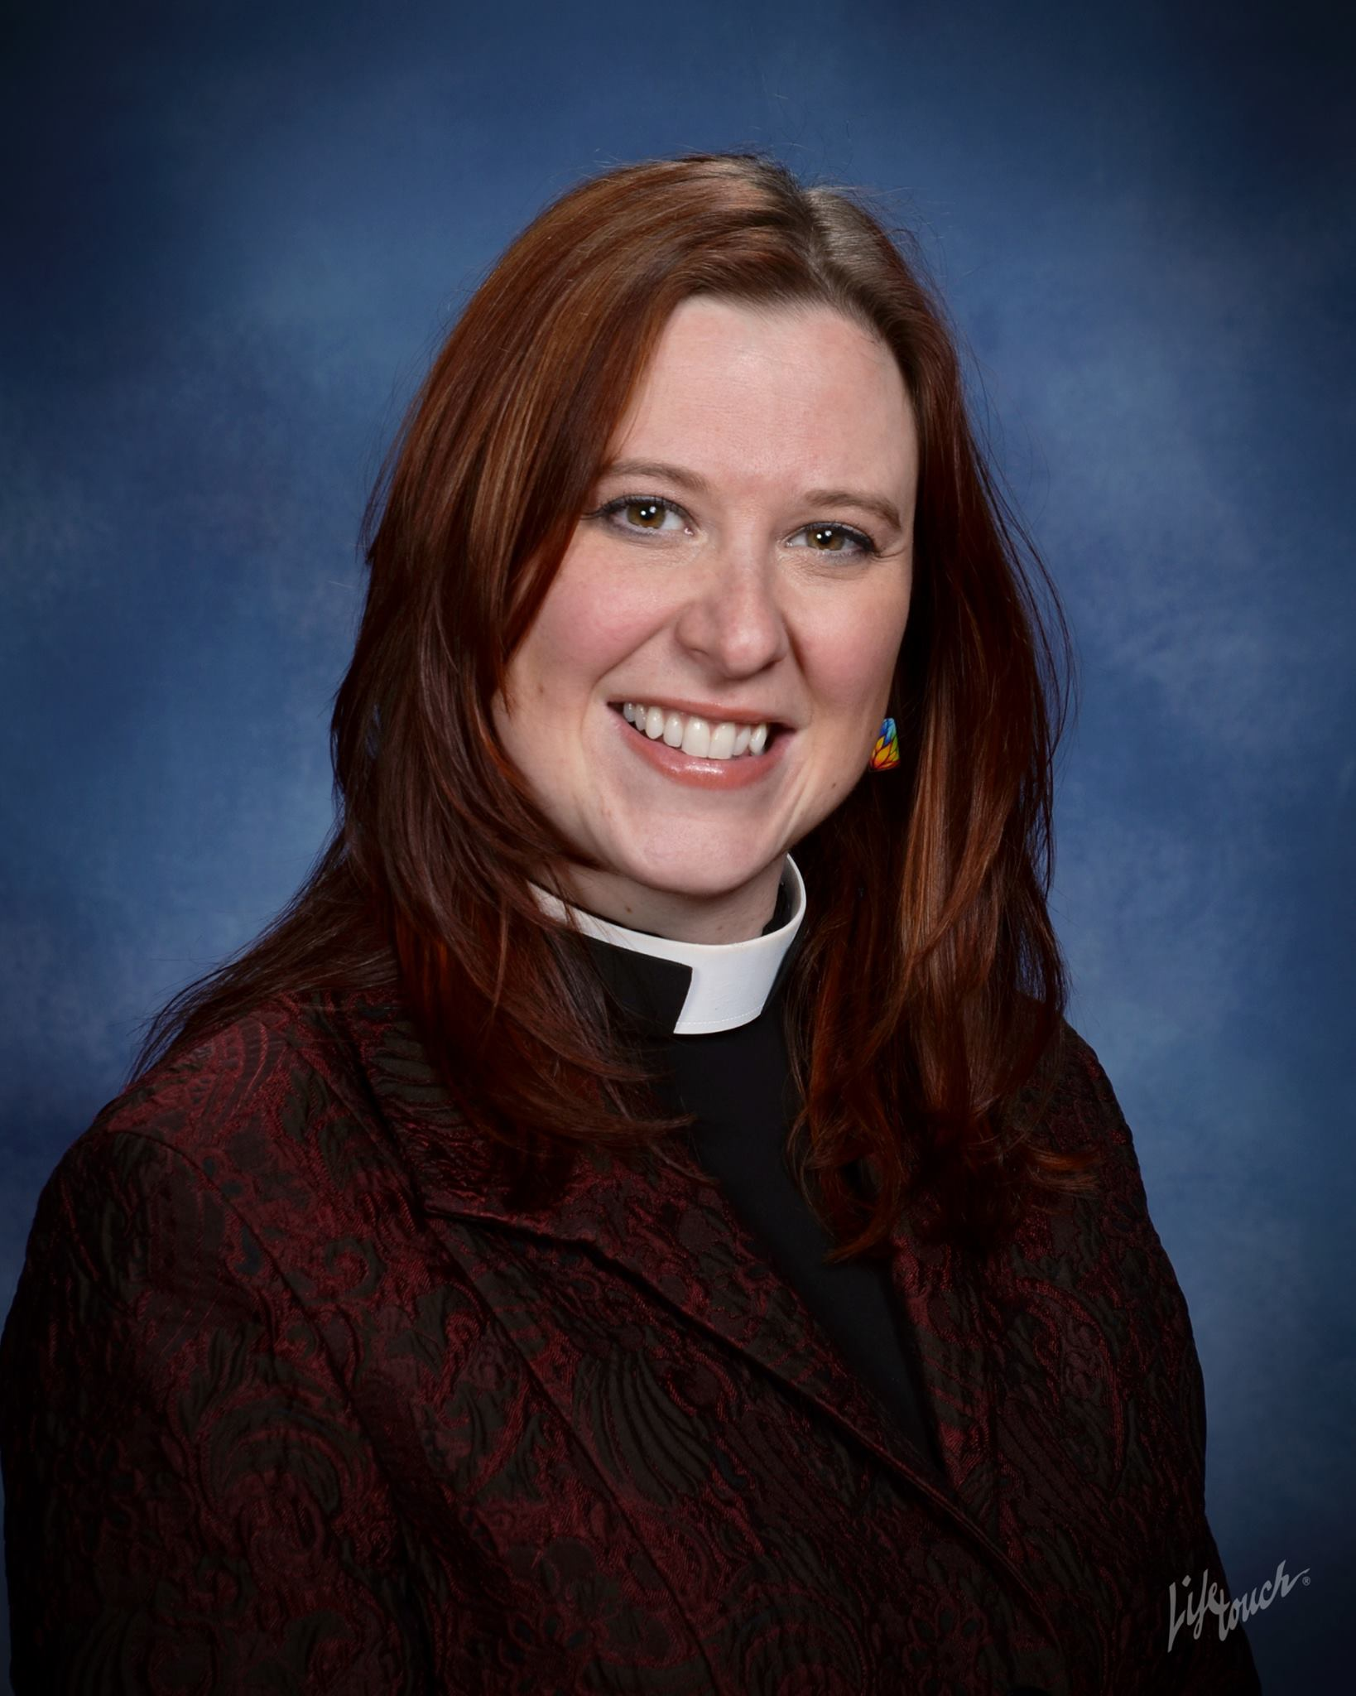 | The Rev. Amanda Zentz is the pastor at Central Lutheran Church in Portland, Oregon. With a passion for baptism and funerals and a love for liturgy, Pr. Amanda digs deep into the traditions of the church to teach the deeper meanings of our ritualized actions. Growing up outside of the church, Amanda was baptized on December 14, 1997 while studying for her undergraduate degree in Theatre Arts from Susquehanna University in Selinsgrove, PA. Amanda went on to receive her MDiv from Pacific Lutheran Theological Seminary in Berekeley, CA in 2004. She was ordained into service in the ELCA in 2005. She is currently in her third call, having served in Medford, OR and Mount Vernon, WA before her call in 2013 to Portland.  Walking as an ally for many years, Pr. Amanda is honored to serve an RIC congregation with passion around welcoming all people to congregational life. She continues to learn and grow in what it means to serve as a public advocacy voice for the LGBTQ community, and other minority groups. Amanda also happens to skate modern Women's Flat Track Roller Derby under the name FeeNix. (For we proclaim that, in his death, Christ Nixed the Fee for our salvation.)
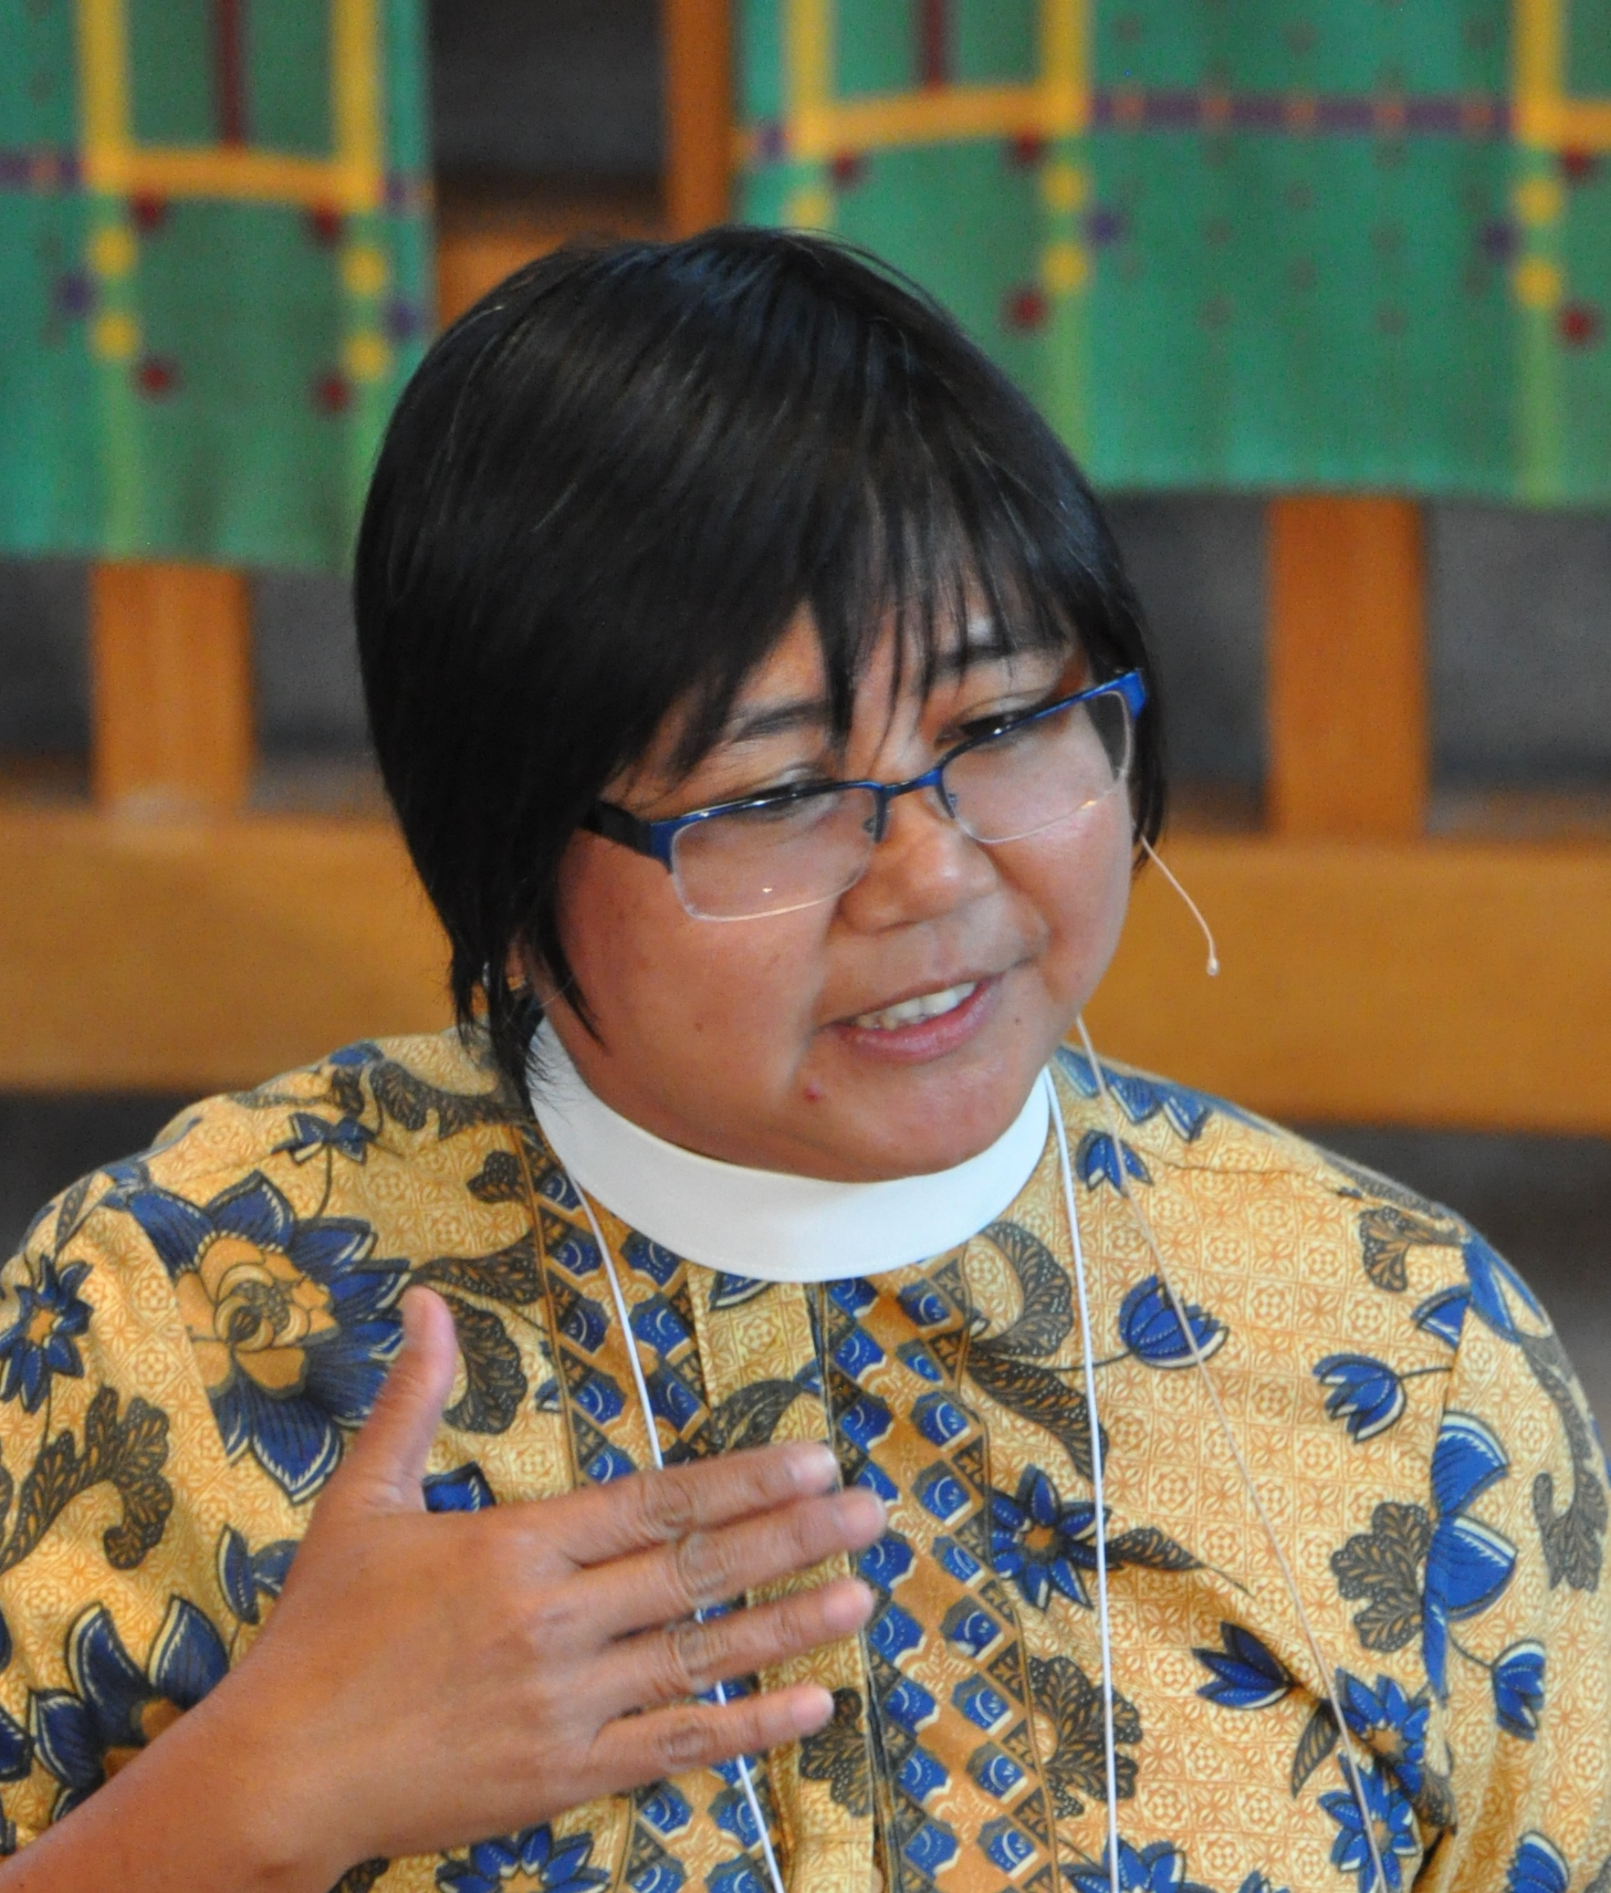 | The Rev. Tita Valeriano is currently building up an evolving progressive faith community in the East Bay Area, California while raising a son, Taal, with her spouse, Jennifer. She has served in various ministries of the church, as parish pastor, campus ministry pastor, and the Lutheran World Federation’s Youth/Young Adult Secretary in Geneva, Switzerland and Regional Officer for North America. Her work has focused on nurturing an ecumenical, multicultural, missional church that invites and includes youth and young adults and people from various cultures, race and class. She is also very involved in justice-oriented and advocacy ministries in the community especially on immigration and economic justice. Recently she participated in various advocacy and accompaniment work on the recently passed bills, Differed Action for Childhood Arrivals, Domestic Workers Bill of Rights, LGBTQ immigrants. Born and raised Lutheran in the Philippines, she was trained in holistic mission. Also trained as a musician contextualizing church music and liturgy, she has traveled in different parts of the world, where she has learned from and worked with renowned church global musicians, and regularly leads creative worship and world music celebrations. Currently she is serving a house church, Way of Grace. For fun, she loves photography, international cooking, traveling and most of all to gather people from various walks of life around a bountiful table.
 | The Rev. Megan Rohrer is the first openly transgender pastor ordained in the Lutheran church, was named a 2014 honorable mention as an Unsung Hero of Compassion by His Holiness the Dalai Lama, received an Honorary Doctorate from Palo Alto University and was a finalist for a Lambda Literary Award in transgender nonfiction.  Currently the pastor of Grace Evangelical Lutheran Church in San Francisco, CA, Pastor Rohrer's Bible Study that Doesn't Suck mobile app and contemporary music masses (Lady Gaga, Beatles, etc) inspire 3,600+ participants a month interact with the weekly justice-centered bible studies. Since 2002, Pastor Rohrer has also served as the Executive Director of Welcome- a communal response to poverty and raised over a million dollars, served 603,000 meals, given away 404,000 pounds of groceries, grown 5 tons of produce in community gardens, given away 18,000 pairs of socks and 1,000 pairs of prescription glasses.
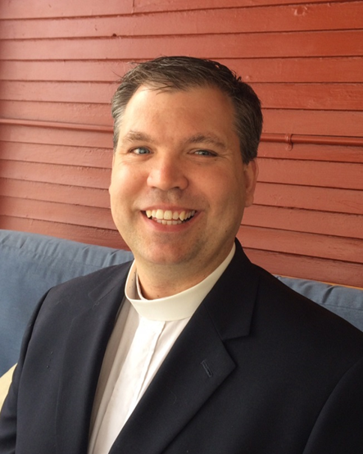 | The Rev. Bradley (Brad) Froslee serves as pastor with the people of Calvary Lutheran Church in Minneapolis, Minnesota. Brad grew up in Vining, Minnesota, and is a graduate of St. Olaf College, Northfield, Minnesota, and Harvard Divinity School, Cambridge, Massachusetts. Prior to serving at Calvary, Brad served as pastor at St. Luke Presbyterian Church PC (USA), Minnetonka, Minnesota, through The Formula of Agreement.  Brad has served as Clergy Chair for Minnesotans United for All Families; Program Retreat chair for Extraordinary Lutheran Ministry (ELM); member of the Clergy table for Isaiah (race and disparities); Brad is the founding Director of The Naming Project’s Teen Summer Camp and subject of the documentary, Camp Out, and served as a co-director of the program. In 2014 Calvary and Brad were awarded a National Clergy Renewal Grant with the Lilly Endowment through Christian Theological Seminary that includes work on racial equity and justice.  Brad and his husband, Bill O’Connor, and their son, Torin, reside in Minneapolis.
 | Tim Feiertag began as the Grassroots Organizing and Training Coordinator for ReconcilingWorks in February of 2012. He has served as co-trainer for over 20 Building an Inclusive Church trainings, helping faith communities create a process to become places of public and intentional welcome to people of all sexual orientations and gender identities. He is a 2009 graduate of Pacific Lutheran Theological Seminary and is approved for ordination in the Evangelical Lutheran Church in America through the Central States Synod. He is a member at St. Paul’s Lutheran Church in Minnetonka, MN.

