Resources for Reconciling In Christ (RIC) Sunday
January 26, 2014
Third Sunday after Epiphany

Introduction
Every year, ReconcilingWorks: Lutherans for Full Participation offers resources for Reconciling in Christ Sunday, the last Sunday of January. This Sunday is recognized ecumenically throughout the welcoming church movement. For faith communities that have made a public stand in welcoming people of all sexual orientations and gender identities, this Sunday is set aside to highlight that welcome.

Again this year, the resources we present for RIC Sunday are based on the Revised Common Lectionary texts appointed for the day, the Third Sunday after Epiphany. As we read through the appointed lessons, we heard themes of God’s call to us, to gather us, comfort us, and send us out. We heard some tension in the call for unity while acknowledging g that things are not yet fully as God intends them to be. Expressions of hope are grounded in experiences of pain.

May this resource help you plan your own RIC Sunday celebration! Let the scripture notes inform your worship and sermon preparations. Use the children’s sermon ideas to discuss your community’s commitment to welcome with your kids. Select hymns from the list below, or seek out new songs to sing. Include or adapt these prayers of the people petitions in your own worship. End your worship with A Recommitment to Reconciliation, or use that as a stand-alone litany with your council or any time you wish to renew your community’s commitment to being a place of welcome for people of all gender identities and sexual orientations. Let these resources be just the beginning of the ways that your worship celebrates, renews, and grows the mission of hospitality and reconciliation to which we hear God calling us.

Should your community be unable to celebrate RIC Sunday on January 26, feel free to select a date that works better for you, such as a date near National Coming Out Day (October 11) or the anniversary of your joining the Reconciling In Christ program, or in conjunction with the local LGBT Pride celebrations. You are encouraged to adapt these resources for use at other times. You are welcome to contact Tim Feiertag (grassroots@reconcilingworks.org) for assistance in creating an RIC Sunday celebration on another day.

As you consider the many ways your community might expand and deepen the commitment you have made through the RIC program, consider also the ways that you can support ReconcilingWorks in reaching out to new potential RIC settings as well as continuing to help current RIC settings deepen what it means to engage in this ministry. Consider taking up a special offering for ReconcilingWorks on this day. Encourage individuals and households to sign up as Reconciling Lutherans or as paid members. If your congregational meeting is being held on or near Reconciling In Christ Sunday, make sure that support for ReconcilingWorks is included in your congregation’s annual budget. For more information on ways to support ReconcilingWorks, visit our website here: www.reconcilingworks.org/get-involved

So that we know how best to serve you, please let us know when your RIC setting celebrates RIC Sunday this year. We would also appreciate your feedback on these resources. Feel free to forward to us other resources that you use in your celebration which we could share with others for future RIC Sunday celebrations.

The Scriptures
Isaiah 9:1-4
Brief background: Zebulun and Naphtali are northern tribes defeated by Assyria. In their dark days, they look ahead with anticipation to the new reign of hope and light. Some name this a Coronation Hymn, for during the hard days with King Ahaz, they looked forward to Hezekiah, or even Josiah. Whether celebrating fresh possibilities with a new ruler, or a great harvest, this text expresses their joy that God will deliver them from the oppression they experience.
- Images of light and darkness can correspond to experiences of living in the closet and living openly. We often think of the “closet” as an individual’s experience, but similarly communities, congregations, and families have these experiences of moving from the oppression of the closet to a more open and freeing time.
- Being an RIC congregation carries the commitment to bring a welcome for LGBTQ people into the light. We don’t just happen to welcome all people, but in a society and church still rife with oppression for the LGBTQ community, we bring this welcome into the public, intentionally into the light.
- For all the beauty and power of light and dark images, these can be problematic in terms of race. Without intending, do we raise up lightness while shunning darkness?
- How interesting to note that this text is assigned each Christmas Eve, as well as this 3rd Sunday in Epiphany in the year A.
- In verse 3, the feelings of joy, freedom, openness, and burdens lifted are palpable.
- For many, these verses bring to mind the recent won legal battles for marriage and other equalities. Even as we celebrate, we anticipate the need for still more justice and a still wider welcome. Joy is tempered by reality.
- In verse 4, the language of rod and bar are powerful and carry their own racial baggage and experience.
- A summer 2013 movie, The Butler, speaks of a similar movement into light and freedom.

Psalm 27:1, 4-9
- In verse 1, consider the boldness of saying, “Do not fear,” in a culture of fear-mongering! This is our calling.
- In verse 4, the writer seeks to dwell or live in the house of the Lord. With the welcome of RIC, this is possible for many who wondered if they’d ever be able to be part of a Christian community. Consider what this house of the Lord may be. Is it necessarily a church? Other community?
- In verse 5, note that the NRSV uses “Tent” while ELW’s Psalm translation has “Sanctuary”. This is interesting given that ReconcilingWorks and this movement began as a “sanctuary” movement, where risk and safety were part of the equation. We’ve come a long way! Consider the implications of permanence between being a tent or being a sanctuary.
- This image goes farther as we know the sense of yearning for a place of worship, a place to call home, a place where one can literally and figuratively raise up one’s head.
- In many RIC settings, straight folks have quite intentionally chosen worshipping communities that are RIC because of the discernment and welcome that this implies. This broadens the movement and richly adds to the diversity in our reconciling communities.
- In verses 7-9, the language of seeking God’s face reminds us of our desire to be part of a community where one’s whole self can be seen. Seek the face of Christ in one another. There are always more faces to seek out.
- In verse 9, it’s helpful to note the experience of alienation in the midst of these words of hope.

1 Corinthians 1:10-18
Brief Background: Here Paul is calling on the people of Corinth stop their divisions and live in the unity of the gospel. Too easily we forget that we belong not to human leaders or institutions, or even specific congregations, but to Christ. The cross becomes our unifier and the powerful center of the gospel’s salvation.
- In an era of division in society and in the church, it’s easy to say, I belong to Redeemer Lutheran, I belong to St. John’s Lutheran. Sometimes this is basic information, sometimes it’s pride, sometimes we seek fervently to understand ourselves and our Christianity over and against someone else’s.
- In the fall of 2013, NALT, Not All Like That, became a talking point for Christians to say publically that conservative voices don’t get to speak for all of Christianity. Here’s information about NALT, including a video clip: http://www.huffingtonpost.com/2013/09/04/not-all-like-that-christians-lgbt_n_3865915.html What does this text say to this movement? Or to our need for such a movement?
- This dynamic of agreement, or unity, even when we aren’t in full agreement is a helpful one to explore. The Churchwide Assembly’s decision in 2009 was a good example of the ELCA saying it’s okay not to be in agreement. Much closer to home, many families are seeking unity even when not in full agreement. In the press about Presiding Bishop Elizabeth Eaton following her election, she had some helpful language around our unity in division. See the Editor’s column in the September 2013 The Lutheran for more.
- At the Churchwide Assembly in 2013 there was conversation about our ministry with people of color. From the floor debates, it becomes clear that even within a community, there are wide ranging feeling and opinions about what language is used to describe a community, and how both the unity and the diversity of a community is lived.
- One thing we’ve learned through years of work organizing in the church and beyond, is the power of relationship. So often we have tried to “get it right” when what is most needed is authentic, genuine relationship, as messy as this can be. This relational process can be seen as foolishness, but even so holds the power of salvation in Christ, and the potential for real and spirited change and movement in the church.
- While Paul’s dialogue about baptism (who he baptized, etc.) is awkward, there is a beauty in the reality that we are baptized in Christ. Period. Being LGBTQ doesn’t and can’t negate this.

Matthew 4:12-23
Brief Background: Soon after John the Baptist was arrested, Jesus begins his public ministry. Echoing John, he proclaims the nearness of God’s reign and calls out four fisher-folk to be his first disciples.
- There is a wideness to fishing with a net; all sorts of things are brought in (many varieties of fish, old boots, waste). Juxtapose this to fishing with a line and a lure, usually a specific type of lure designed to catch a specific species of fish. What does this say about our sense of mission and the wideness of Jesus’ mission? Many in the LGBTQ community can tell of times when we were “thrown back in” for our gifts were offered but not received.
- As Jesus calls out Simon Peter and Andrew, James and John, we are invited to ask: What do we leave behind in order to follow Jesus into the future? What do we need to leave behind? What do we need to have or to carry? For some, standing up and joining in the freedom to marry movement is an act of discipleship, sometimes separating families. As we fight for all families, sometimes we are called out from our families of origin.
- The comments in verse 23 about disease and sickness speak of not only physical illness, but also social ills. Reparative therapy is much debated but a real and painful experience for many. Talk of healing in the church can be heard with caution because of this and other experiences.
- Verse 12 is interesting. In a time of crisis following John’s arrest, Jesus withdraws to Galilee. What assumptions might others have made about Jesus’ reasons for doing this?
- In verse 17, the call to repent is powerful. We are to turn around, to begin anew. What does this mean in this movement? What does this kingdom of heaven look like and how does it relate to the call in our time?
- Isn’t it notable that Jesus begins with four fisher-folk? They don’t seem to represent much diversity! Zebedee the father isn’t seen, nor is he called. What does this say about the need to be seen in order to be called?

Children's Sermon Ideas
1 Corinthians 1:10-18
Many of us can name a time that we’ve disagreed with someone else. If you dare, ask children if they’ve ever had a fight with someone—a sibling, a friend, maybe even their parents. It’s hard when we don’t get along, when we disagree, when something seems unfair.
Acknowledge that grown-ups don’t always get along well either. Sometimes we disagree about really important things. Even in the church we sometimes disagree with the people we are supposed to show the greatest love to. Perhaps you could name some of the current hot button issues in your own setting.

The Apostle Paul was writing to people who were arguing and fighting about issues that were really important to them. But Paul reminds them of what’s most important: we all belong to Christ. No matter what may seem like a division to us, we are always united in Christ and his love and care for us. So even when we don’t agree about issues, we still sing the same hymns, we pray prayers together, we pass the peace and say I’m sorry, and we share a meal at the same table. Together we are the body of Christ for the world and there is nothing that can separate us from one another, because we all belong to Christ.

Matthew 4:12-23
Use a rod, reel and fishing lure as your props and talk with the children about fishing—why people who do it for recreation enjoy it. It’s relaxing and quiet. It’s exciting to reel in a fish that you caught. It’s reenergizing to be in nature and connects people to their creator. Sometimes, people who fish will throw back fish that aren’t big enough or the kind of fish they were hoping to catch for dinner.

Jesus finds four fishermen as he was walking along the sea shore. These fishing people used nets, not poles. When they cast their net into the sea, a whole bunch of different kinds of fish would be caught in the nets.

Imagine what that says about the mission Jesus calls these fisher people and us to do. Instead of throwing people back who do not fit our understanding of a fish worthy of keeping, we too are invited to cast the net wide. Children and adults are called to invite everyone to be part of the community and to live in the joy of Christ.

Hymn Suggestions

These hymns were chosen to give you a starting point as you think about congregational singing on RIC Sunday. The most common themes they include are the church’s unity in diversity, Christ the light, the welcome and healing of all people and our common call to discipleship. All these themes are found in the lectionary readings for the third Sunday after Epiphany, and also speak to how we as church look for the light of Christ to lead our journey towards justice and inclusivity for all God’s children.

In addition to proclaiming and responding to the lectionary themes, these are hymns that attempt to avoid gendered language for God. Instead they use many names and images for God and God’s people in the hope of expanding our imaginations of how we relate to God and each other. They also avoid binary gender language for humanity (such as “brothers and sisters”) because this language can reinforce feelings of exclusion and invisibility particularly for transgender people or those with more fluid gender identities.

All numbers and titles below refer to the hymnal Evangelical Lutheran Worship, but of course there are many other great resources for inclusive and faithful hymns. You may wish to look at other favorite songbooks from your congregation’s history or music used by ecumenical neighbors, particularly other LGBT-inclusive congregations. Whatever you choose to sing together, blessings on your song!

#306 “Come, Beloved of the Maker”
With its themes of Christ’s light, the call of discipleship and moving through suffering to peace, this song seems specifically written for today’s lectionary readings. For congregations or individuals who have been hurt it speaks of God’s love and accompaniment.

#314 “Arise, Your Light Has Come”
This epiphany song of praise to Christ the light calls us to “bind up the brokenhearted ones,” those wounded by church and society as many LGBTQ folks have been. With its call to go forth confidently in God’s power it would work well as a sending hymn.

#326 “Bless Now, O God, the Journey”
As the name suggests, the themes include God’s accompaniment through the hard and easy times of discipleship. This would also be a natural choice for a sending song.

#548 “Rise, O Church, like Christ Arisen”
A natural choice for a sending hymn that proclaims with praise the church’s mission as disciples of a living faith looking always towards the future.

#576 “We All Are One in Mission”
This hymn focuses on the unity of the church’s calling in the midst of all of our diversity. It could function well as a hymn of the day in response to a sermon on the Gospel or 1 Corinthians.

#611 “I Heard the Voice of Jesus Say”
A song of healing and rebirth in Jesus as light of our lives who gives those in stress and transition hope for the future and assurance of light in dark times.

#641 “All Are Welcome”
This hymn of broad welcome illustrates many faithful ways congregations are able to move from hurt and injustice to mutual community and sharing the love of God. To sincerely declare everyone welcome can be especially precious to LGBTQ people who may have heard elsewhere that they are not.

#648 “Beloved, God's Chosen”
We all long to be reminded of the love of God, but especially those who may have heard that they are outside of God’s love long to affirm that they are chosen and bound together with the whole church in that love.

#651 “Oh, Praise the Gracious Power”
This hymn echoes the Isaiah reading in praising God for freedom from oppression, in particular the freedom in Christ who makes us one without fear of our differences.

#715 “Christ, Be Our Light”
The lyrics are a frank acknowledgement that we are not yet living in a peaceful and just world, but one where inequality of all sorts surrounds us. We ask for Christ’s light to guide us in service to one another as we use our diverse gifts.

#798 “Will You Come and Follow Me”
With the calls to the disciples in the gospel reading, we are asked if we will allow ourselves to be transformed by discipleship in ways that push us out of our comfort zones and into the vulnerability of following Jesus.

Prayers of the People

As God’s beloved children, let us pray that the light of Christ shine on the nations, the church, and all those in need.

Strengthen the church as it proclaims a message of welcome and hospitality.
When we face division, unite us in Christ and in our common baptism.

Bring light to nations silenced by oppression, conflict, hunger, and violence.
Where there is gloom and despair, bring your joy and freedom.

Open our eyes to the beauty of the Lord, not only in sacred space, but in the world you have made.
Teach us to wisely care for the earth and its resources.

Drive away the sickness of disease, addiction, anxiety, prejudice, and discrimination.
Draw to your heart all who are marginalized due to race, gender identity, sexual orientation, religion, or socioeconomic status.

Empower those who work for marriage equality, and give courage to all who struggle to come out to their families, churches, or workplaces.
We give thanks for faithfulness in the past, O God, even as we seek your guidance for the journey ahead.

Strengthen our congregations to cast a wide net as we proclaim the reign of God in our time.
May our communities welcome not only diverse kinds of families, but also those who are single, divorced, or widowed.

Gather us, with all your saints, into the wide net of your grace, that we may follow you with faith and confidence in your mercy.
Let your light shine upon us that we may bear your divine image.

God of splendor and light, hear our prayers and illumine us with the radiance of your glory made known in Jesus Christ our Savior.
Amen.

Liturgical Option

A Recommitment to Reconciliation
L: Beloved children of God, we have been gathered together at this time, in this place. God’s grace surrounds us, cleansing us from our sin, opening to us the words of scripture, feeding us with God’s very presence, and empowering us to proclaim good news: healing, salvation, and joy! As we prepare to go out from this place, let us pause to remember the ministry that has been given us.

Hear these words from 2 Corinthians 5
So if anyone is in Christ, there is a new creation: everything old has passed away; see, everything has become new! All this is from God, with whom we have been reconciled through Christ, and by whom we have been given the ministry of reconciliation; that is, in Christ God was reconciling the world to Godself, not counting the people’s trespasses against them, and entrusting the message of reconciliation to us.

People of [your congregation name here], the powers of this world will attempt to impose old distinctions upon you—male and female, slave and free, Jew and Greek—barriers to keep you separated from one another. Will you remember that in Christ you have been made a new creation?

C: We will, and we ask God to help and guide us.

L: The powers of this world will attempt to restrict your vision, to keep you from seeing the outcast, the poor, and the stranger. Will you remember that God is reconciling the entire world to Godself?

C: We will, and we ask God to help and guide us.

L: The powers of this world will continue to count your trespasses against you, telling you that you are far too flawed, too insignificant, too wounded to make any difference. Will you remember that God has called you to be God’s messenger?

C: We will, and we ask God to help and guide us.

L: Let our heads be lifted up; let us be united in purpose; let us follow Christ. The yoke of our burden has been broken!

C: Amen!

About the Authors
 | Tim Feiertag began as the Grassroots Organizing and Training Coordinator for ReconcilingWorks in February of 2012. He is a 2009 graduate of Pacific Lutheran Theological Seminary and is approved for ordination in the ELCA through the Central States Synod. He is a member at St. Paul’s Lutheran Church in Minnetonka, MN.
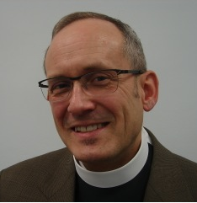 | Rev. Craig Mueller has served as pastor of Holy Trinity Lutheran Church in Chicago since 1999. Mueller has a master of divinity from the Lutheran School of Theology in Chicago (LSTC), a degree in music education from Gustavus Adolphus College, and a certificate in spiritual direction from the Shalem Institute for Spiritual Formation. In 2013 he graduated from LSTC with a Doctor of Ministry degree. His thesis topic was: Any Body There: Embodied Liturgy, Technology, and Human Authenticity. Craig and his partner, Ernest Vasseur, live in the Edgewater neighborhood of Chicago.
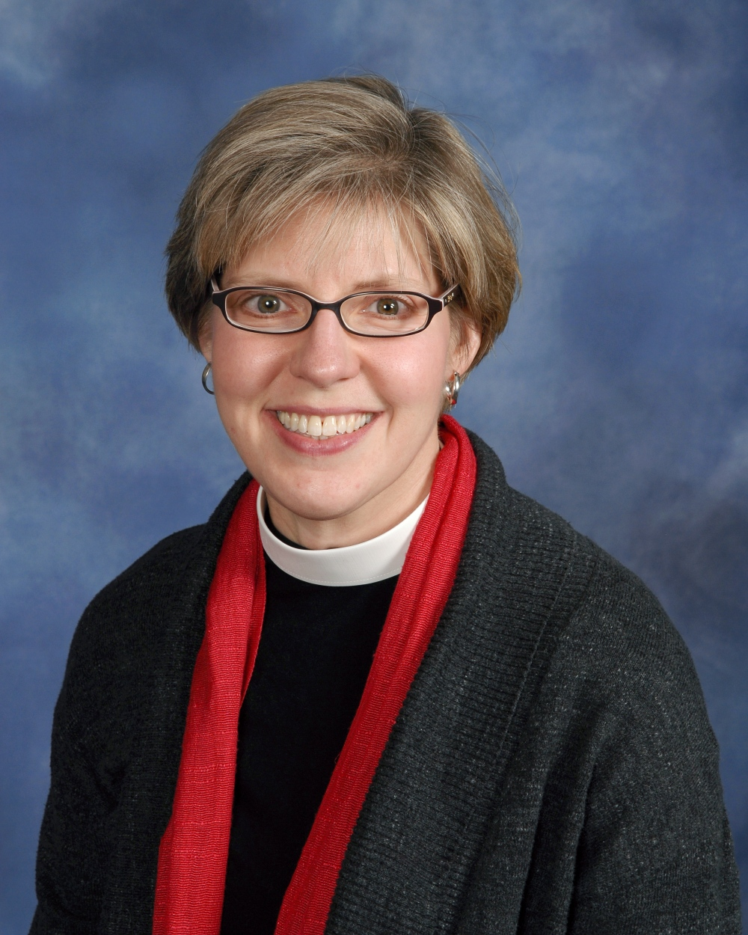 | Rev. Jen Nagel serves as pastor at Salem English Lutheran Church in Minneapolis. Jen has served at Salem for 10 years through a time of dramatic and spirited transformation as they have developed an ecumenical partnership with two other congregations with whom they now share SpringHouse Ministry Center. Jen has an M.Div. from the Divinity School at University of Chicago and did Lutheran studies at Lutheran School of Theology at Chicago. Jen was ordained extra-ordinarily and was part of the Extraordinary Lutheran Ministries roster prior to being received onto the ELCA Clergy Roster in 2010. Jen shares life with her spouse, Rev. Jane McBride, pastor at First Congregational Church of Minnesota, UCC, and their four year old daughter.
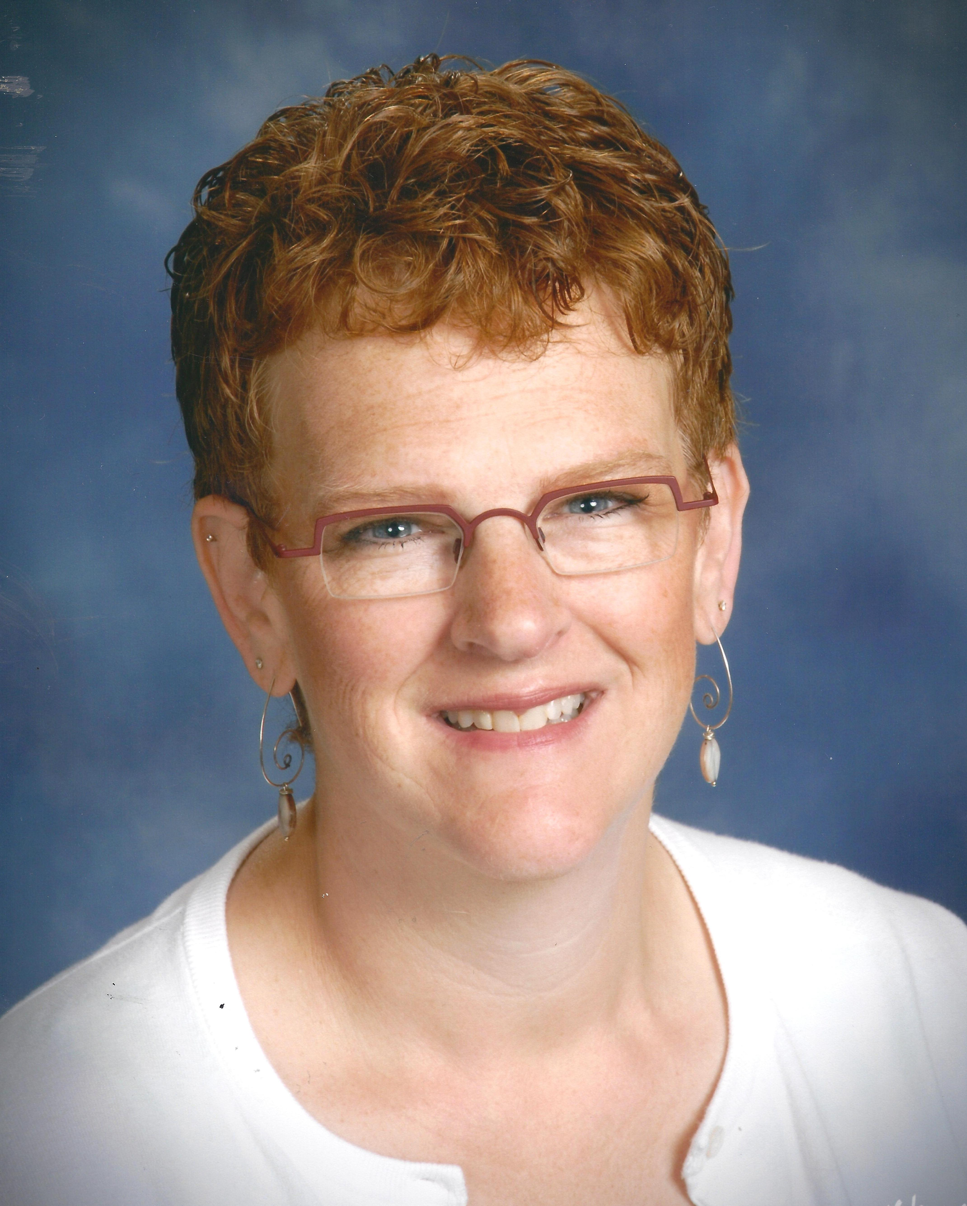 | Rev. Michelle L. Sevig serves on the pastoral staff of Holy Trinity Lutheran Church in Chicago. She is also a part-time hospice chaplain at NorthShore University Healthsystem. She and her partner, Julie Sevig, have been together for 19 years and have three adorable children: Peder, Oliver and Annika.
 | Marissa Sidars is a Master of Divinity student at the Lutheran School of Theology at Chicago. She is currently doing her pastoral internship at Salem English Lutheran Church in Minneapolis, MN, a congregation with close ecumenical partnerships and a strong commitment to welcome. Marissa graduated from St. Olaf College in 2006 with a Bachelor of Music in Harp Performance. She and her partner Maggie live in south Minneapolis.

