
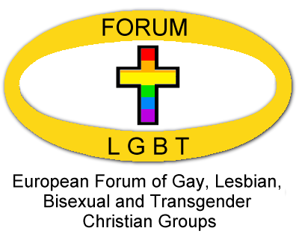

Joint Communiqué
July 5, 2008

This joint communiqué between the European Forum of Gay, Lesbian, Bisexual and transgender Christian Groups and Lutherans Concerned/North America was prepared at the “Hearts on Fire” Biennial Assembly of LC/NA in San Francisco and was issued on July xx, 2008 by the respective organizations with the intent of giving further definition to their mutual accompaniment. Such potential activities as indicated below are not seen as either limiting or obligatory but exemplify activities for future focus. Any actions which would require financial support would require the approval of the respective Boards of the two organizations. Such examples of activities would include working to:

- Exchange representatives at their respective annual and biennial meetings;
- Consider the development of Joint Statements and Press Releases on specific issues as seen appropriate;
- Consider the development of joint policy, concept, and/ or strategic documents as seen appropriate;
- Consider the development and implementation of a strategic plan for advancing the recognition of the importance of religious witness, specifically with the context of LGBT issues, by targeted international, regional and/or national organizations; and
- Consider the development of international programs regarded relative to respective concerns of the two organizations, including aspects of design, sponsorship, and implementation.

Emily Eastwood  Executive Director  Lutherans Concerned/North America  Philip W. Moeller  Director of International Programs Lutherans Concerned/North America  About Lutherans Concerned:  Lutherans Concerned/North America works for the full inclusion of lesbian, gay, bisexual, and transgender Lutherans in all aspects of the life of their Church and congregations. Lutherans Concerned provides a place of comfort and safety. Lutherans Concerned reaches out and teaches that Christ's message, the Gospel, is for everyone equally. Lutherans Concerned calls for the blessing of committed and covenanted same-gender relationships, and for the ordination of those called to minister. | Hilde Raastad  Co-President, European Forum of LGBT Christian Groups  Enric Vilà I Lanao  Co-President, European Forum of LGBT Christian Groups  About European Forum:  The European Forum of LGBT Christian groups exists to work for equality for LGBT people within and through the Christian churches of Europe. We are a growing ecumenical network of 38 groups from 19 countries. We support one another and any individuals who are facing discrimination. We also represent the member groups in discussions with ecumenical bodies, national churches, and civil and political organizations.

